Hello - Northwest Kilmarnock Bowling Club has made an application to the Wellbeing Fund for money to purchase equipment for, mainly children at primary 5, at our 3 local schools - Onthank, Mount Caramel and Hillhead - but this we hope will lead to us setting up a youth/junior section in the Club (I think we already have 9 potential youth/junior members). We have sufficient members to run these coaching sessions, but we need equipment and storage facilities. So please consider supporting us on our bid via online voting. We are in the Kilmarnock Locality Project and are number 17 on the list.

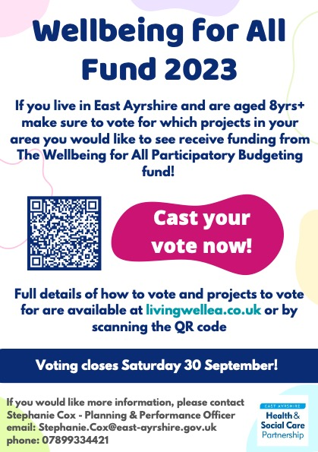

Details of projects available to vote for are on the Wellbeing Website: https://www.livingwellea.co.uk/partnership-working/funding/wellbeing-for-all-participatory-budgeting-fund/

Online voting can be accessed directly via Smart Survey: https://www.smartsurvey.co.uk/s/WfAVoting2023/

